Effects of Temperature on Carbon Resistors

Peter Sieg
Pinkerton Academy

ABSTRACT

The goal of the experiment was to determine the feasibility of using carbon resistors at different temperatures. Tests were conducted by measuring the resistance of a set of carbon resistors at various temperatures. The various temperatures were achieved using a water cooler, liquid nitrogen (LN), and dry ice. It was found that the resistors were able to gauge the temperature more accurately at temperatures below 150 K. The resistors used were able to measure temperature at relatively low temperatures while at room temperature, they seemed ineffective.

INTRODUCTION

The experiment attempts to explore the factors bearing on the resistance of a carbon resistor. It is known that there are many factors that determine how the resistance might change, such as temperature, type/brand, size of the resistor, humidity, and magnetic fields (Anon. 1985). Generally, the resistors are known to be extremely sensitive to changes in temperature at temperatures lower than 20 K. They are also relatively insensitive to changes in pressure, radiation, and humidity when exposed for short periods of time. Because of their sensitivity at low temperatures, scientists and laboratory technicians use calibrated carbon resistors as thermometers. They are ordered from a factory with calibrated data about the specifications of each resistor at various temperatures.

This experiment is aimed at testing these resistors at warmer temperatures (above 200 K). Because common resistors such as car headlights that are exposed to extreme hot and cold temperatures during the different seasons, it is probable that the change in resistance will not be large. That resistance, however, is expected to be measurable . The feasibility of these resistors will be determined by the ability to measure that resistance at the higher temperatures. If the resistors are able to provide accurate measurements at higher temperatures, they may provide a cheap and accurate alternative to regular thermometers.

MATERIALS AND METHODS

Materials
In the tests, 20 Allen Bradley 120 Ω carbon resistors were tested and labelled by number and a tag from 1-20. For resistors R1-R6, the resistance was measured using an inexpensive multimeter with an accuracy of ±1 Ω. For the rest of the tests, a more precise multimeter was used with an accuracy of ±0.001 Ω. The thermometer used in all trials was a thermocouple which was accurate to ±1 K. For the room temperature tests, a water cooler was used, shown in Figure 2. The cooler was able to chill water to temperatures down to 278 K. For R7-R20, the resistance of the connecting wire between the multimeter and resistor was measured as a way to be more accurate.

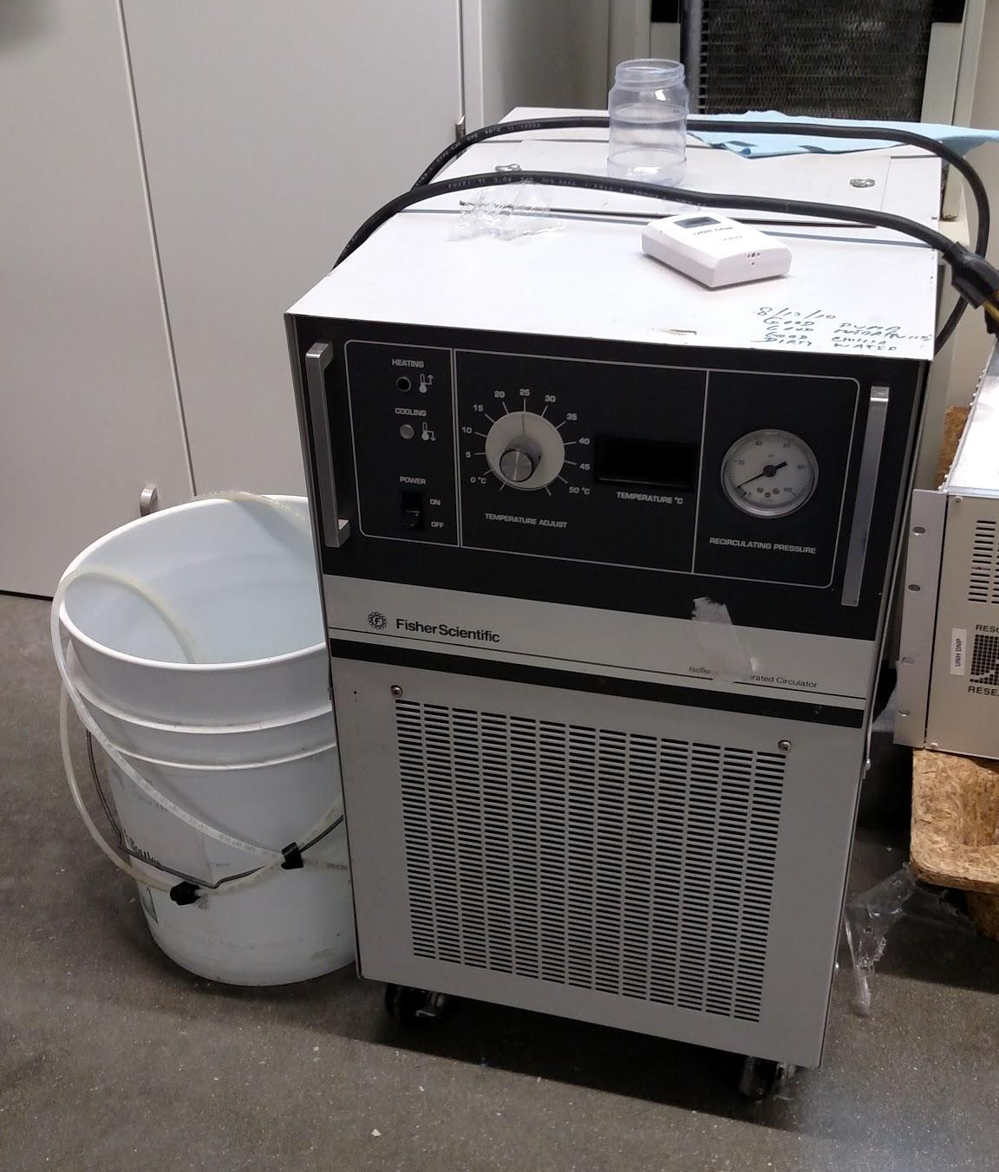
Tests in water bath
In order to set up and run the water cooler, a small (around 350 mL) Erlenmeyer flask and water was needed. On the back of the water cooler, there are two tubes, one for intake and the other output. These tubes are placed into the flask which is a so a closed system is created where the water is continuously cycled through. To control the cooling of the water, the temperature setting of the chiller was decreased at small increments so that temperature could be decreased slowly. A thermocouple was placed into the water to measure the exact temperature of the flask.

The actual tests of the resistors was accomplished by placing the resistors in the water while recording the resistance and temperature. This is done by clamping the resistor by the leads closely to the actual resistor as shown by Figure 3. For the tests of R1-R6, the resistance was recorded when the water was in motion. This has led to slightly inconsistent results. For the remaining trials the resistance was recorded when the water was at rest. This was possible by cooling the water to a specific temperature, stopping the flow of water, and measuring the resistance. Many times, it was possible to measure the resistance of multiple resistors at a specific temperature because water would stay at a specific temperature for several minutes. It was often necessary to wait for a few minutes for the resistance to settle at a specific amount because it takes time for the actual temperature of the resistor to adjust. The data was recorded for about five to six trials between room temperature (about 20 K) and 5 K. Because the process is somewhat time-consuming, each resistor was tested once but the process is easily repeatable.

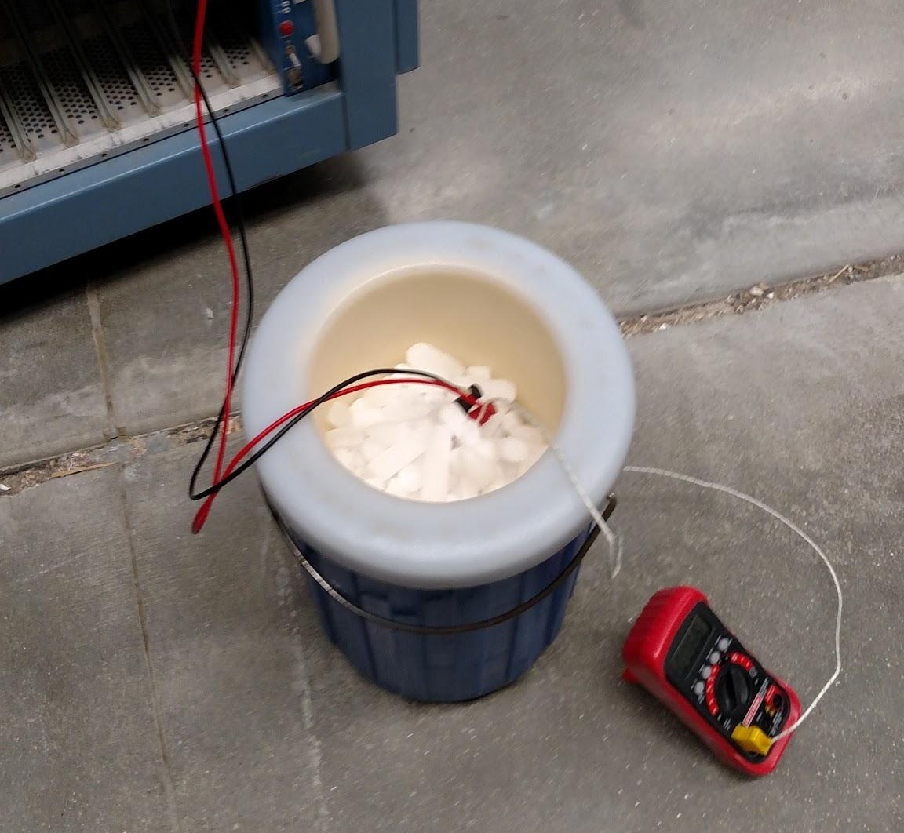
Tests in dry ice
The resistance was measured at a known temperature of dry ice as a way to gather more calibration points. This was accomplished by gathering dry ice in an insulated container shown in Figure 4. Each resistor was clamped in the same way as the previous trials. The resistance was measured when the resistor was placed into the insulated container. It was recorded after a few minutes when the resistance settled at a certain number.

Tests in LN
The tests in LN were accomplished similar to the way that the dry ice tests were. The LN was gathered in an insulated container and measured using the same methods of dry ice. Extra precautions needed to be taken for LN such as wearing insulated gloves and safety goggles because of the dangerous nature of the substance.

Tests using ice water
With the help of LN, ice water could be made easily. This was done by adding a small amount (10-25 mL) of LN to a 250 mL plastic beaker (glass will shatter), and then adding water to the rest of the beaker. The water would almost instantaneously freeze so it was broken up and stirred using a small metal rod or screwdriver. It is necessary that both water and ice are in the beaker so the temperature remains at 273 K. The tests were conducted by placing the resistors in the beaker in the same way as the previous trials.

Analysis of data
To analyze the data, the information was plotted in tables and graphed using a equation finding/graphing program called Scientific Python. This specific program was not necessary but a program that allows for a custom equation input is required. The temperatures must be inputted in Kelvin and the resistance in Ohms. The actual resistance is found by subtracting the resistance found in the wires from the recorded data. To analyze the room temperature data alone, a linear regression equation was used to find the equation. When using all of the data, a more specific equation was needed where “r” is resistance, “t” is temperature and “A,” “B,” and “C” are constants: $\frac{1}{T}=A+Bln(r)+{C(ln(r))}^{3}$. The graphs were adjusted to fit the equation and the equation information was printed onto the graph.

RESULTS

Each resistor out of the set acted slightly differently with changes in temperature; however, as a whole, the resistance increased with the decrease in temperature. Out of the resistors, some produced data that fit the equation with less error. These were R3, R7, and R8 as shown by their graphs. The first three numbers provide the values of the constants given by the equation while the remaining values are indicators of error. The error in these resistors was significantly less than the rest of the set. The rest of the resistors either produced too much error to produce a curve or were not accurate enough. At lower temperatures around 80 K, it has been found that a change of 1 Ω equates to a change of less than 1 K, which results in precise measurements. At higher temperatures, a change of 1 Ω equates to a change of about 15K which provides imprecise measurements. Every resistor performs differently, but overall resistors have been shown to work more effectively as thermometers below 150 K.

DISCUSSION

The aim of the experiment was to determine the feasibility of using carbon resistors as thermometers at various temperatures. This was accomplished and agrees with the idea that the resistance would change less at higher temperatures. The results show that the resistance change in resistors is relatively small at room temperature while it is much greater at lower temperatures such as 100 K. It was already known that the resistor would be able to provide more precision at lower temperatures and this was confirmed in multiple trials. However, the relationship between resistance and temperature is not a linear relationship. Therefore, a separate equation was used to determine relationship between temperature and resistance. The equation is not perfect because there is no known equation to model the real world data but there are very close estimates. Although this equation best fit the data that was found in the tests, different equations have been developed for different temperature ranges. Experts have found that a separate equation is needed for temperatures solely less than 4 K and another for temperatures less than 1 K. This is because different resistors work most effectively at different temperature ranges. For example some work best between 0-1 K while others between 70-90 K (Anon. 2013). Each works for its designed temperature range. The equation used in this experiment could be used because it was designed for the overall relationship at all temperatures.

The experiment could be improved by including more resistance measurement at various temperatures or repeating the process on the resistors. These would reduce the errors in the graph and cause reduce the chance that a bad measurement was taken. In addition, a more accurate thermometer may be used instead of the thermocouple in order to provide a more accurate temperature. Some of the error that is unaccounted for in the data is the fact that the resistance does not seem to settle at a specific value at a certain temperature. Instead, it seems to fluctuate between a set of values which causes inconsistency in the results. This can be prevented by letting the resistor stay at the certain temperature for a longer period of time or by conducting more trials on the same resistor. Another unaccounted error is that humidity, pressure, and other similar factors were not factored into the data. Together these may provide slight skews of data but were individually judged to be insignificant to the overall experiment. Altogether a majority of the data was accounted for or can be easily adjusted for.

On the feasibility of the resistor as a thermometer, it was confirmed that it could be used as a precise thermometer at low temperatures. The resistors are relatively inexpensive, costing about $2 for a set of 20. Additionally, it has been determined that the resistors can provide accurate measurements within 0.1 K or less at temperatures below 125 K (Anon. 2013). A major drawback to these inexpensive resistors is that the calibration often requires a great amount of time and they are not interchangeable. Additionally, many chemical resources are necessary to provide accurate results. If one does not want to deal with the drawbacks, he or she may purchase a pre-calibrated resistor from a company at a higher price. The decision process comes down to making a choice of whether or not the cost is important.

Nevertheless, the resistors can be used in many places where a conventional thermometer would be difficult to use. These places could be in small confinements where a resistor is the only item that can fit or areas that are extremely cold such as outer space or the inside of an insulated container. A resistor would also be feasible in an area that is already surrounded by wires and the resistance could easily be measured. It wouldn’t be helpful in computer systems however because these systems operate at higher temperatures that surpass the precision capability of the resistor. In conclusion, the carbon resistors can be used as thermometers but work most effectively at temperatures below 150 K, but each individual thermometer most effectively works at a certain range.

LITERATURE CITED

Anonymous. 1985. Carbon Resistor Thermometers. <http://www1.bipm.org/utils/common/pdf/its-90/TECChapter11.pdf>.
Anonymous. 2013. Cryogenic Thermometers. Meyer Tool & Mfg. <http://mtm-inc.com/reduce_project_risk/cryogenic_thermometers/>.

